**预习报告**

**实验内容**

1、数值判别电路

(a) 用门电路设计一个组合逻辑电路，它接收一位8421BCD 码 B3B2B1B0，仅当 2 < B3B2B1B0 < 7 时输出 Y 才为 1

(b) 用门电路设计一个组合逻辑电路，它接收 4 位 2 进制数 B3B2B1B0，仅当 2 < B3B2B1B0 < 7 时输出 Y 才为 1

2、用三种方案设计实现 3 位二进制原码转补码电路（3 位二进制数仅考虑 0 和负数，且已省去符号位）：

(a) 全部用门电路实现

**实验设计方案**

1. **输入、输出信号编码**

1-(a)： 输入信号：B3B2B1B0表示输入的8421BCD码

输出信号：Y表示是否满足2 < B3B2B1B0 < 7条件，满足为1，不满足为0

1-(b)： 输入信号：B3B2B1B0表示输入的4位2进制数

|  |  |  |  |  |
| --- | --- | --- | --- | --- |
| B3 | B2 | B1 | B0 | Y |
| 0 | 0 | 0 | 0 | 0 |
| 0 | 0 | 0 | 1 | 0 |
| 0 | 0 | 1 | 0 | 0 |
| 0 | 0 | 1 | 1 | 1 |
| 0 | 1 | 0 | 0 | 1 |
| 0 | 1 | 0 | 1 | 1 |
| 0 | 1 | 1 | 0 | 1 |
| 0 | 1 | 1 | 1 | 0 |
| 1 | 0 | 0 | 0 | 0 |
| 1 | 0 | 0 | 1 | 0 |
| 1 | 0 | 1 | 0 | 0 |
| 1 | 0 | 1 | 1 | 0 |
| 1 | 1 | 0 | 0 | 0 |
| 1 | 1 | 0 | 1 | 0 |
| 1 | 1 | 1 | 0 | 0 |
| 1 | 1 | 1 | 1 | 0 |

输出信号：Y表示是否满足2 < B3B2B1B0 < 7条件，满足为1，不满足为0

2-(a)： 输入信号：B2B1B0表示输入的3位2进制原码

输出信号：Y2Y1Y0表示输出的3位2进制补码

|  |  |  |  |  |
| --- | --- | --- | --- | --- |
| B3 | B2 | B1 | B0 | Y |
| 0 | 0 | 0 | 0 | 0 |
| 0 | 0 | 0 | 1 | 0 |
| 0 | 0 | 1 | 0 | 0 |
| 0 | 0 | 1 | 1 | 1 |
| 0 | 1 | 0 | 0 | 1 |
| 0 | 1 | 0 | 1 | 1 |
| 0 | 1 | 1 | 0 | 1 |
| 0 | 1 | 1 | 1 | 0 |
| 1 | 0 | 0 | 0 | 0 |
| 1 | 0 | 0 | 1 | 0 |
| 1 | 0 | 1 | 0 | x |
| 1 | 0 | 1 | 1 | x |
| 1 | 1 | 0 | 0 | x |
| 1 | 1 | 0 | 1 | x |
| 1 | 1 | 1 | 0 | x |
| 1 | 1 | 1 | 1 | x |

1. **列出真值表**

1-(a)的真值表 1-(b)的真值表

|  |  |  |  |  |  |
| --- | --- | --- | --- | --- | --- |
| B2 | B1 | B0 | Y2 | Y1 | Y0 |
| 0 | 0 | 0 | 0 | 0 | 0 |
| 0 | 0 | 1 | 1 | 1 | 1 |
| 0 | 1 | 0 | 1 | 1 | 0 |
| 0 | 1 | 1 | 1 | 0 | 1 |
| 1 | 0 | 0 | 1 | 0 | 0 |
| 1 | 0 | 1 | 0 | 1 | 1 |
| 1 | 1 | 0 | 0 | 1 | 0 |
| 1 | 1 | 1 | 0 | 0 | 1 |

2-(a)的真值表

1. **逻辑化简**

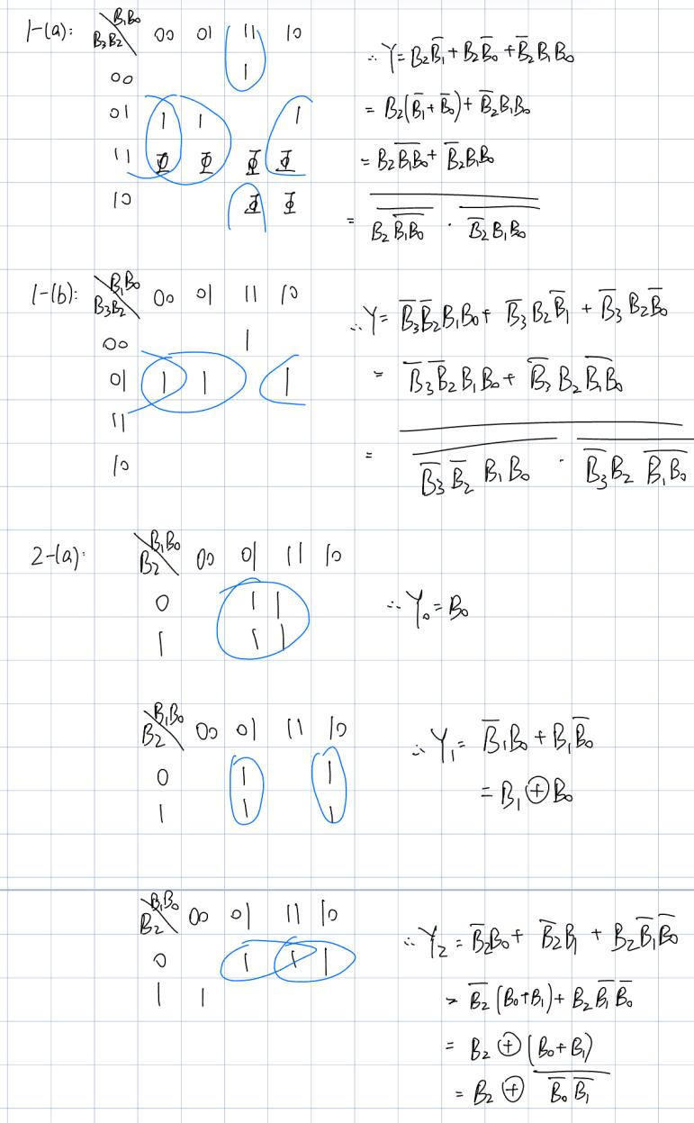

1. **逻辑电路图**
2. (a):

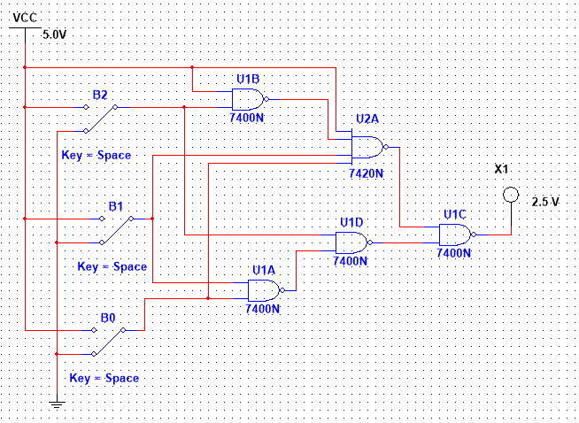

1. (b):

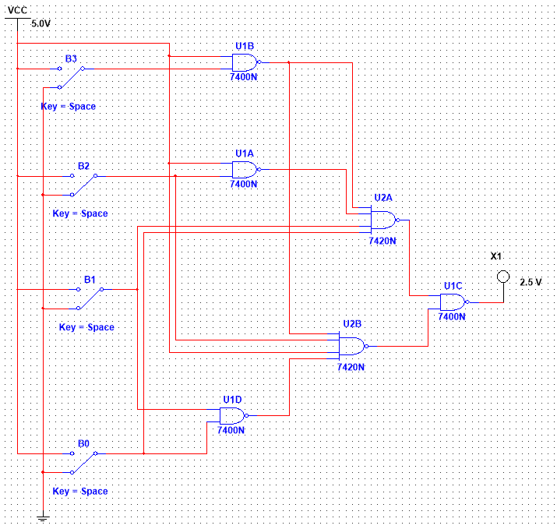

1. (a):

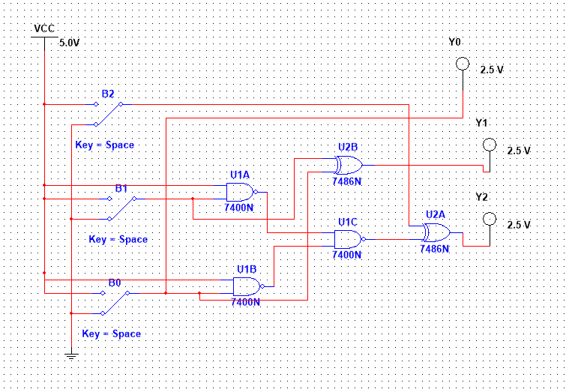

1. **硬件连接示意图**

**1-(a):**

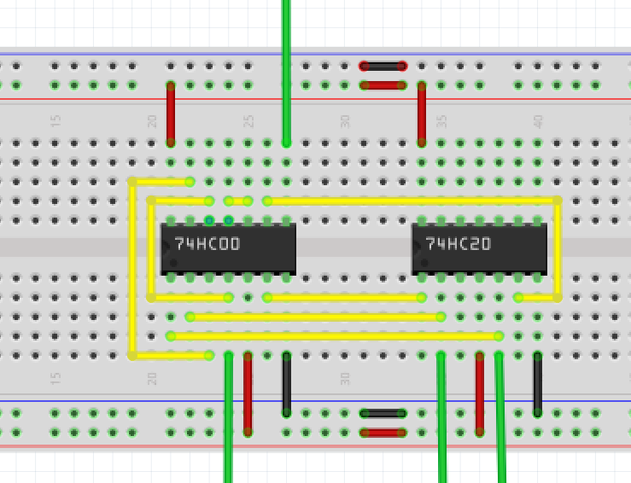

上：Y

下：B2,B0,B1

1-(b):

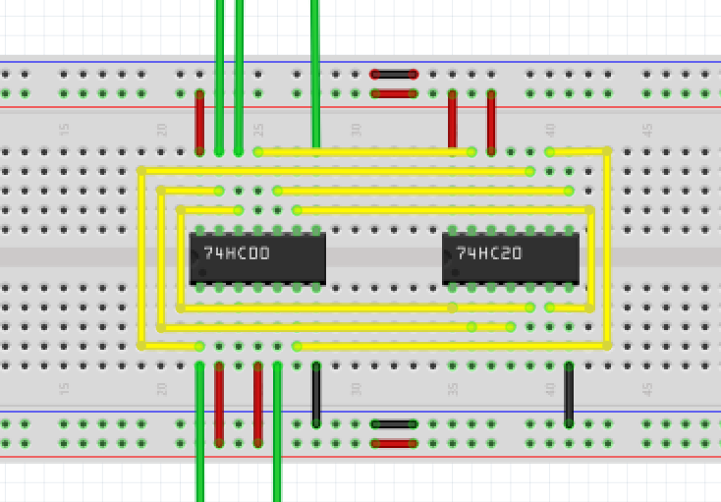

上：B0,B1,Y

下：B2,B3

2-(a):

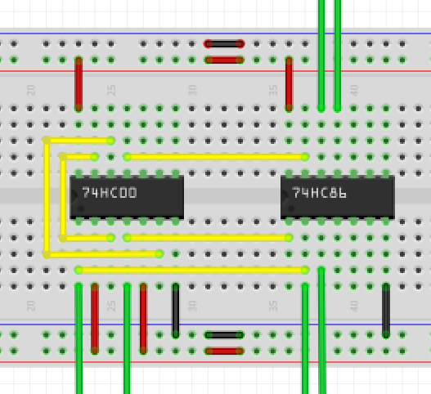

上：B2,Y2

下：B0,B1,Y0,Y1

**实物搭接图**

**1-(a)**

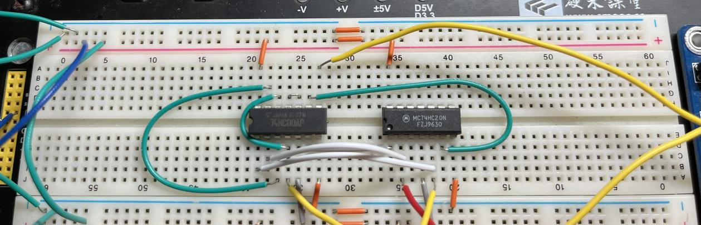

**1-(b)**

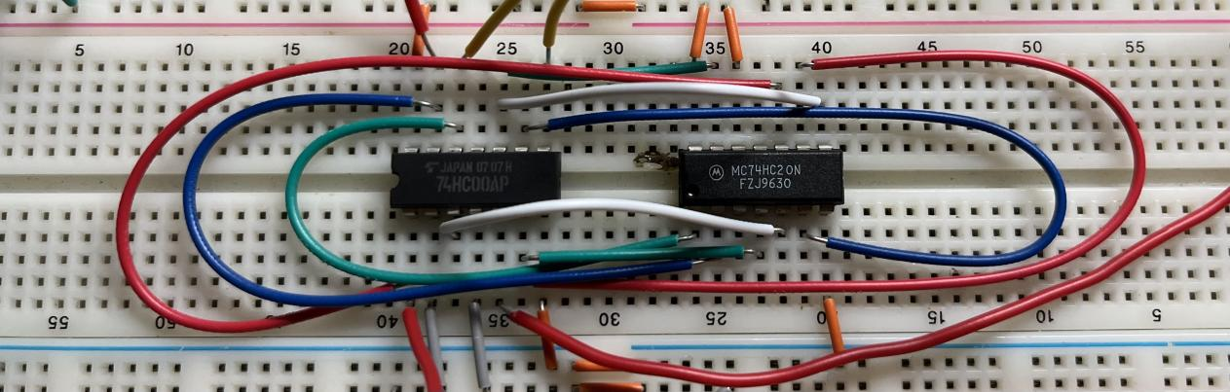

**2-(a)**

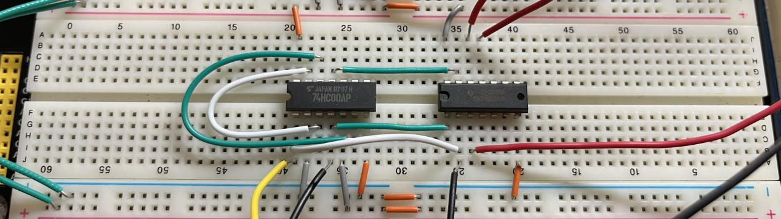

**测试方案**

3个输入信号，用实验箱上的逻辑电平开关实现，1 个输出端连接到实验箱上的 LED，按照真值表的要求，拨动逻辑电平开关改变输入信号值，遍历 10种输入组合，并观察输出信号值，输出 LED 亮则输出为1，灭则输出为 0，将测试结果填入下表。

|  |  |  |  |  |  |  |  |  |  |
| --- | --- | --- | --- | --- | --- | --- | --- | --- | --- |
| B2 | B1 | B0 | Y | 测试结果 | B2 | B1 | B0 | Y | 测试结果 |
| 0 | 0 | 0 | 0 |  | 0 | 0 | 0 | 0 |  |
| 0 | 0 | 1 | 0 |  | 0 | 0 | 1 | 0 |  |
| 0 | 1 | 0 | 0 |  | 0 | 1 | 0 | x |  |
| 0 | 1 | 1 | 1 |  | 0 | 1 | 1 | x |  |
| 1 | 0 | 0 | 1 |  | 1 | 0 | 0 | x |  |
| 1 | 0 | 1 | 1 |  | 1 | 0 | 1 | x |  |
| 1 | 1 | 0 | 1 |  | 1 | 1 | 0 | x |  |
| 1 | 1 | 1 | 0 |  | 1 | 1 | 1 | x |  |

4个输入信号，用实验箱上的逻辑电平开关实现，1 个输出端连接到实验箱上的 LED，按照真值表的要求，拨动逻辑电平开关改变输入信号值，遍历 16种输入组合，并观察输出信号值，输出 LED 亮则输出为1，灭则输出为 0，将测试结果填入下表。

|  |  |  |  |  |  |  |  |  |  |  |  |
| --- | --- | --- | --- | --- | --- | --- | --- | --- | --- | --- | --- |
| B3 | B2 | B1 | B0 | Y | 测试结果 | B3 | B2 | B1 | B0 | Y | 测试结果 |
| 0 | 0 | 0 | 0 | 0 |  | 1 | 0 | 0 | 0 | 0 |  |
| 0 | 0 | 0 | 1 | 0 |  | 1 | 0 | 0 | 1 | 0 |  |
| 0 | 0 | 1 | 0 | 0 |  | 1 | 0 | 1 | 0 | 0 |  |
| 0 | 0 | 1 | 1 | 1 |  | 1 | 0 | 1 | 1 | 0 |  |
| 0 | 1 | 0 | 0 | 1 |  | 1 | 1 | 0 | 0 | 0 |  |
| 0 | 1 | 0 | 1 | 1 |  | 1 | 1 | 0 | 1 | 0 |  |
| 0 | 1 | 1 | 0 | 1 |  | 1 | 1 | 1 | 0 | 0 |  |
| 0 | 1 | 1 | 1 | 0 |  | 1 | 1 | 1 | 1 | 0 |  |

3个输入信号，用实验箱上的逻辑电平开关实现，3个输出端连接到实验箱上的 LED，按照真值表的要求，拨动逻辑电平开关改变输入信号值，遍历8种输入组合，并观察输出信号值，输出 LED 亮则输出为1，灭则输出为 0，将测试结果填入下表。

|  |  |  |  |  |  |  |  |  |
| --- | --- | --- | --- | --- | --- | --- | --- | --- |
| B2 | B1 | B0 | Y2 | Y1 | Y0 | 测试结果 | 测试结果 | 测试结果 |
| 0 | 0 | 0 | 0 | 0 | 0 |  |  |  |
| 0 | 0 | 1 | 1 | 1 | 1 |  |  |  |
| 0 | 1 | 0 | 1 | 1 | 0 |  |  |  |
| 0 | 1 | 1 | 1 | 0 | 1 |  |  |  |
| 1 | 0 | 0 | 1 | 0 | 0 |  |  |  |
| 1 | 0 | 1 | 0 | 1 | 1 |  |  |  |
| 1 | 1 | 0 | 0 | 1 | 0 |  |  |  |
| 1 | 1 | 1 | 0 | 0 | 1 |  |  |  |